**Embedded Electrical Integration for Startup, Teleoperation, and Future Autonomy in Unmanned Ground Vehicles (UGVs)**

Jason L. Souter

School of Engineering & Technology, School of Science, Miami Dade College

STEM Research Institute

Fred Mawudzro, M.S.

Autonomous Ground Vehicles (AGVs) are robotic platforms designed to operate with limited human intervention. This project focuses on studying the embedded and electrical systems integration of the Robotnik Guardian, an Unmanned Ground Vehicle (UGV) intended for autonomous applications in search and rescue and combat search and rescue scenarios. This study aims to understand and improve the Guardian’s current functionality by establishing safe startup behavior and implementing reliable motion control, understand the robot’s supervised electrical architecture, validating safety-critical components such as fuses and relays, and deploying a Robot Operating System (ROS)-based motion control system to ensure consistent startup and teleoperation. Currently, this vehicle is controlled manually through a joystick interface integrated through ROS; future development will focus on achieving autonomous functionality through sensor integration, navigation planning, and simulation through various hardware tests and iterative validation of power logic through the Central Nervous System (CNS). This project represents a study of embedded system diagnostic skills, an enhanced system-level understanding of control systems, and advances the overall readiness of the platform for future expansion into autonomous applications such as the integration of Artificial Intelligence (AI) and a custom User Interface (UI) to enable the robot to sense and respond intelligently during field deployment.

1. **Introduction**

The Robotnik Guardian is a mobile robot built by Robotnik Automation. It’s designed for applications in areas such as security, inspection and research. The Guardian is also known for its high mobility, which allows the robot to move in difficult environments to access other kinds of platforms such as stairs and slopes. The methods of mobility result in tracks and wheels. It can integrate attachments such as sensors and actuators. Weighing 120Kg, the robot can carry up to 100 Kg of additional equipment. The Central Processing Unit (CPU), or the “brain” of the robot, is running on an open-source framework, Robot Operating System (ROS). It’s a middleware that helps with communication between robots’ systems. The Guardian’s embedded computer (PC) is programmed with Linux (Robotnik, n.d.). But what makes a robot? It’s a machine that can sense its environment, process information, and act upon it (Cameron & Tracey Hughes, 2016). The Robotnik Guardian doesn’t fit the definition thoroughly, however, the robot is being developed to do so.

**Additional Features:**

|  |  |
| --- | --- |
| **Batteries**: 48 VDC/16 Ah | **Communication**: Wifi 802.11n/Radio/Cable |
| **Embedded PC**: Intel BayTrail J1900 | **Connectivity**: Ethernet/USB External Ports |

Robotics can be applied to many fields such as transportation, exploration, healthcare, and manufacturing. In this case, the Robotnik Guardian Tank will be applied in a field called “Field Robotics.” Field Robotics is a branch of robotics focused on developing and deploying robots that operate in unstructured, dynamic, and often challenging environments outside of controlled factory settings. These robots are designed to navigate and perform tasks in settings like disaster response, where conditions are unpredictable and require advanced sensing, perception, and decision-making capabilities. Search and Rescue (SAR) is a subfield of Field Robotics, which is the search for and provision of aid to people who are in distress or imminent danger. The sub-fields within SAR depend on the type of terrain such as mountain SAR, ground SAR, urban SAR, combat SAR on the battlefield, avalanche SAR, and air-sea SAR over water.

As mentioned earlier, the conditions of the environment in SAR require sensing, perception, and decision-making capabilities. Since the Guardian is an autonomous robot in-development, that will be used in SAR, it will need to have sophisticated sensors such as cameras, Lidars, and algorithms to understand their surroundings and navigate effectively. According to the article “Recent Advances in Robotics and Intelligent Robots Applications,” “Autonomous navigation involves enabling robots to move and navigate complex and dynamic environments without human intervention. This includes developing algorithms for localization, path planning, obstacle avoidance, and decision making under uncertainty.” (Song, Q, & Zhao, Q., 2024). What will make the Guardian Autonomous? This can be labeled into four (4) areas: perception, decision-making, action, and adaptation.

Firstly, perception is an area which focuses on the Guardian relying on sensors (cameras, LiDAR. Radar, etc.) to gather information about their environment. This allows the Guardian to detect obstacles, navigate, and identify objects. Secondly, decision-making is also a much-needed feature, in which the Guardian’s onboard computer processes the data collected by the sensors. Algorithms and machine learning models analyze this data to make decisions about actions like path planning, obstacle avoidance, or object manipulation. Based on the decisions made, the actuators (motors, grippers, etc.) carry out the necessary actions. This could involve moving, manipulating objects, or interacting with the environment in other ways. Lastly, the Guardian will also be able to adapt to changing conditions, learn from its experiences, and improve its performance over time.

As the Guardian functionality progresses, it will be applied in Combat Search and Rescue (CSAR), which is a specialized military operation focused on rescuing personnel in hostile or dangerous environments. It’s a field within Personnel Recovery (PR) in military, specifically Air Force, that is a mission focused on the recovery and reintegration of isolated personnel. It’s generally a process of returning individuals who were separated from friendlies during operations. This concept is typically performed after information gathering, specifically Intelligence, Surveillance, and Reconnaissance (ISR). ISR is a mission that involves gathering information about potential adversaries and the battlefield to support military operations. The intelligence collected allows CSAR teams to plan and execute missions, increasing the chances of successful recovery and minimizing risks. For the Guardian to sustain CSAR missions, the materials needed will need to be self-reliant and adaptive. The three (3) major areas include physical protection, power & endurance, and communication systems.

Electrical readiness is also essential for enabling safe operation, teleoperation, and future autonomous functionality in unmanned ground vehicles. It ensures that all power distribution systems, including relays, fuses, converters, and safety circuits, function correctly and in the proper sequence. Without stable and verified electrical infrastructure, critical components such as motor drivers, the Central Nervous System (CNS), and onboard computing systems may fail to initialize or operate unpredictably. In teleoperated mode, electrical readiness guarantees that the Robot Operating System (ROS) can reliably communicate with hardware interfaces, interpret joystick inputs, and execute motion commands without interruption. As the system evolves toward autonomy, the demand for continuous sensor integration, path planning, and data processing further increases the importance of electrical stability. Proper electrical validation ensures that sensors, processors, and actuators receive consistent power, enabling reliable decision-making and motion control. Ultimately, establishing electrical readiness provides the foundation for system safety, operational consistency, and scalable autonomy in real-world environments.

To cover the overall goal, to understand the tank’s overall functionality, there was one roadblock the team had discovered: mobility failure. When the team got their hands on the tank, it was discovered that the robot wouldn’t move, although the manual displays the instructions on how to move the tank with the given controller. Meaning, it’s supposed to move with no configuration. Various attempts to troubleshoot the tank were performed. However, there was no progress. After so many attempts, it was discovered that the tank wouldn’t move unless there’s a monitor plugged into the CPU.

1. **Model Establishment**

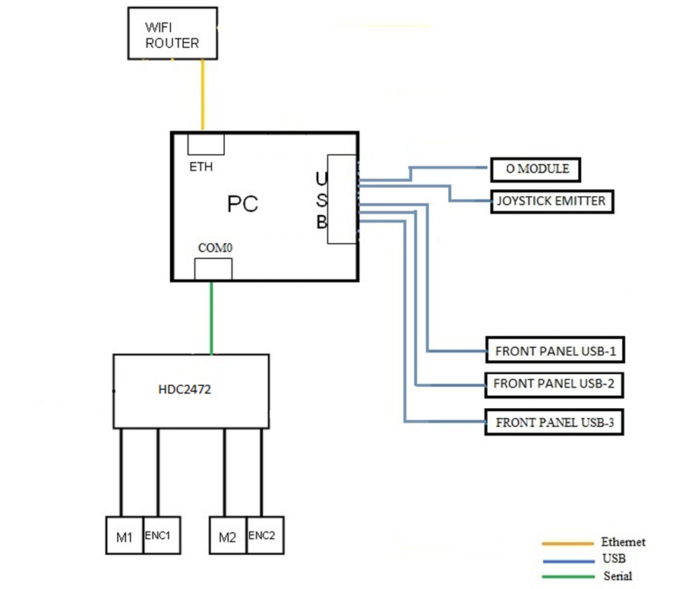

(Figure 1 - *Communications diagram*)

Shown above is the communications diagram. The ethernet (ETH) relates to the WIFI Router, which is connected to the PC. Five (5) USB ports are displayed, attaching the O Module, Joystick Emitter, and the three (3) Front Panels. The “HDC2472” is the Motor Controller, which is responsible for managing and controlling the movement of DC motors (M1 and M2) based on commands received from other parts of the robot’s system. It’s part of the Control System which can be labeled part of the Central Nervous System. Lastly, we have encoders (ENC1 and ENC 2), which is for closed-loop motor control, where the desired motor speed or position is compared with the feedback from the encoders to adjust. In the Guardian robot platform, joystick control is achieved using a wireless USB joystick that transmits radio frequency (RF) signals from the controller to a USB receiver connected to the robot’s onboard computer. When the joystick is moved, button presses, and analog inputs are encoded as digital signals and transmitted over RF (typically in the 2.4 GHz ISM band). These signals are received by the USB dongle plugged into the robot, which acts as a wireless interface.

Once the RF signal is received, the USB dongle emulates a Human Interface Device (HID), allowing the operating system (Linux Ubuntu) to interpret joystick data as standard input events. The Robot Operating System (ROS) runs a node such as “joy_node” or “teleop_twist_joy”, which subscribes to these joystick inputs and publishes corresponding ROS messages (like /joy and /cmd_vel topics). These messages contain velocity commands (linear and angular) that are interpreted by the robot’s motor controller or motion control stack.

This control pathway enables real-time manual operation of the robot, allowing the user to move the tank forward, backward, and rotate using familiar gamepad controls. The entire process is wireless from the joystick to the receiver, but local and wired from the receiver to the CPU and ROS nodes. This system provides a safe and efficient bridge between human input and robotic motion control, critical for testing and early development before autonomous behaviors are enabled.

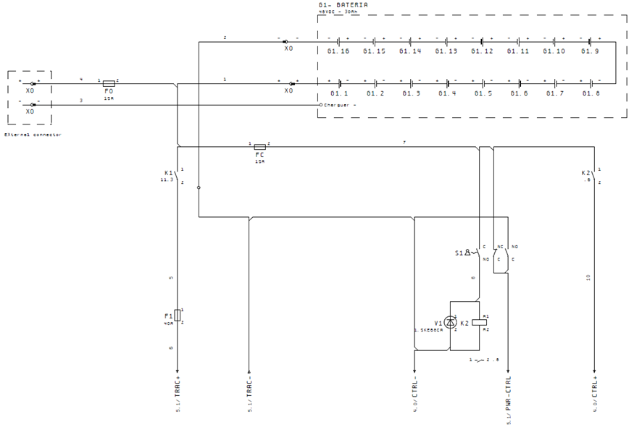

(*Figure 2 - Power Supply Diagram*)



(*Figure 3 - Control Panel*)

The robot receives the power supply from the batteries (G1) of 24V. Behind the supply connector, power splits into a direct supply and a supervised supply. The supervised supply powers the motor drivers and elevator through contactor K1, which disconnects when the emergency button is pressed. The direct supply powers control devices via a DC/DC converter and are active only when switch S1 is ON. For safety, turning off S1 also disconnects the supervised supply.

1. **Methodology**
   1. **Electrical Systems Diagnosis**

Conducted continuity testing of safety-critical components (relays, fuses, wiring paths) and verified voltage paths from battery to CNS, relays, and motion control board.

* 1. **Supervised Power Pathway Validation**

Traces and documented the startup logic and supervised supply routing. The LED status indicators were observed on the HDC2472 to confirm system health.

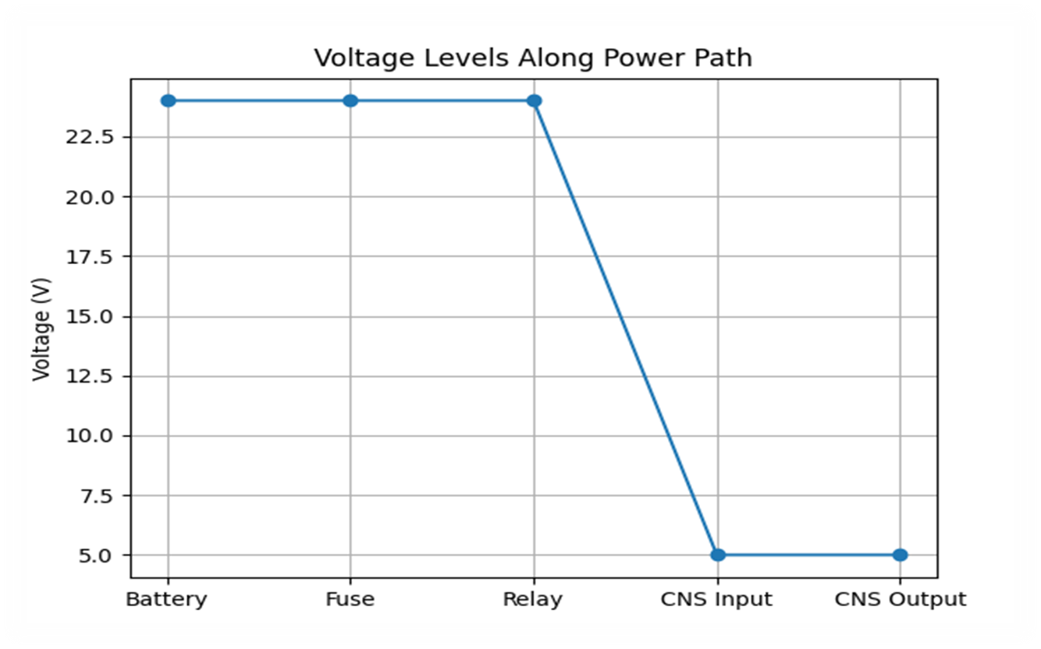

(*Figure 4 – Visual graph of level of voltage and pathway*)

* 1. **Real-time Data Logging**

Conducted data logging on CPU for communication with notepad. This is used to capture what is being executed.

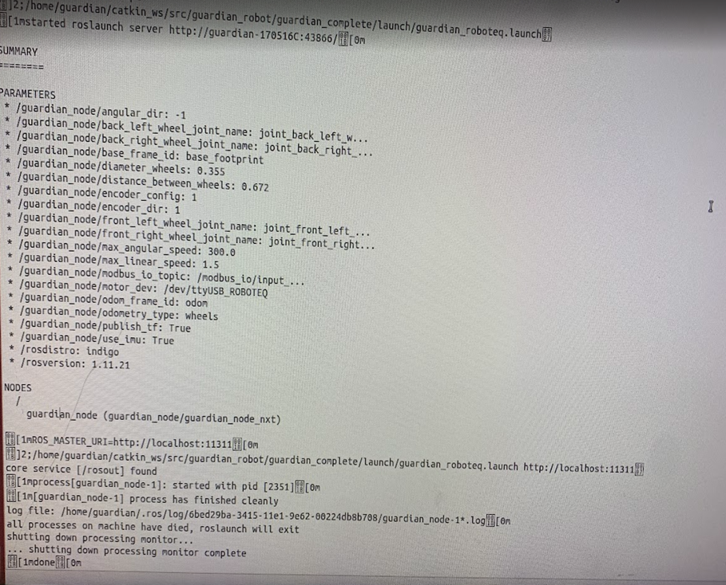

(*Figure 5 - Captured Data from CPU*)

1. **Results**

The results from all the methods mentioned were successful due to the knowledge gained about the tank. The tank, as of July 21, 2025, will not move unless there’s a monitor plugged in to the CPU. A short-term fix is plugging in a HDMI 4K UHD, Virtual Display Dummy (Headless Ghost Adapter), manipulating the Guardian into thinking there is a monitor plugged in. Although this may have solved the issue for now, in the long run, this is not a valid solution. The overall goal, however, was a success. The work that was done ensured the knowledge of the functionality of the Robotnik Guardian. In the future, there are opportunities to proceed solving the issue with the Guardian robot.

1. **Conclusion**

By bridging electrical diagnostics with robotic software, this work ensured reliable system startup, validated safety-critical pathways, and enabled remote motion control. These efforts directly contribute to the robot’s readiness for mentioned goals.

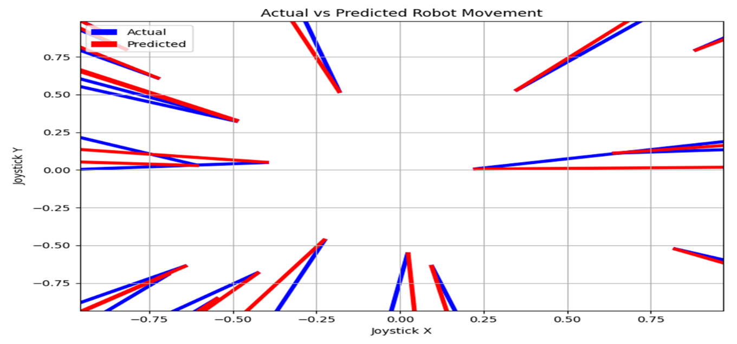

(*Figure 6 - Visual Predictions for future autonomy*)

1. **Acknowledgments**

This research was conducted at the Miami Dade College North Campus Robotics Club space, which provided the necessary tools, environment, and equipment for development and testing. Special thanks are extended to Fred Mawudzro for his mentorship and technical guidance throughout the project. Appreciation is also given to Sarah Rosales, Paulina Olaiz, Erick Licona, and Rene Gonzalez for their collaborative support and contributions. And additional thanks go to all members of the robotics club who assisted.

**References**

Guardian Robotics. (n.d.). *Guardian Robot technical manual* [Unpublished internal document]. Provided by former employee, June 2025.

Hughes, C., & Hughes, T. (2016). *Robot Programming: A Guide to Controlling Autonomous Robots*. Que. Retrieved from https://ptgmedia.pearsoncmg.com/images/9780789755001/samplepages/9780789755001.pdf

Open Source Robotics Foundation. (n.d.). *Robot Operating System (ROS)*. Retrieved August 7, 2025, from https://www.ros.org/

Robotnik Automation. (n.d.) Robot Guardian. https://pdf.directindustry.com/pdf/robotnik/mobile-robot-guardian/177504-659930.html

Robotnik Automation. (n.d.). *Robotnik: Mobile robotics solutions*. Retrieved August 7, 2025, from https://robotnik.eu/

Song, Q., & Zhao, Q. (2024). Recent Advances in Robotics and Intelligent Robots Applications. *Applied Sciences (2076-3417)*, *14*(10), 4279. https://doi.org/10.3390/app14104279